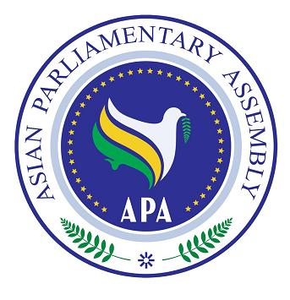
APA/Decision/ 2013/02
10 December 2013

APA Decision
Troika - plus

The Plenary requests the Secretary-General to call for and arrange, in coordination with the current APA President, the meeting of APA Troika-Plus, whenever necessary, but not fewer than three times a year, at the APA Headquarters or elsewhere, and urges APA Troika and all other member parliaments to actively participate in such meetings to review major issues of international concerns to Asia and generate credible, high-caliber and timely reports for consideration by APA Executive Council.

